Implementing DFF

(Add descriptive flexfield columns to all of your entity tables)

1. To add descriptive flexfield columns into your database table, Define a column for each descriptive segment, ATTRIBUTE1 through ATTRIBUTEn

(type VARCHAR2, length 1 to 150, all columns the same length, NULL ALLOWED).
Define Structure Information Column ATTRIBUTE_CATEGORY, is used to identify your descriptive flexfield structures.

CREATE TABLE XXDFF_TABLE
(EMPNO NUMBER,
ENAME VARCHAR2(64),
HIREDATE DATE,
JOB VARCHAR2(30),
SALARY NUMBER(10),
ATTRIBUTE_CATEGORY VARCHAR2(150),
ATTRIBUTE1 VARCHAR2(150),
ATTRIBUTE2 VARCHAR2(150),
ATTRIBUTE3 VARCHAR2(150),
ATTRIBUTE4 VARCHAR2(150),
ATTRIBUTE5 VARCHAR2(150),
ATTRIBUTE6 VARCHAR2(150)
)

2. Register your table with Oracle Application Object Library

AD_DD.REGISTER_TABLE('V-SAT','XXDFF_TABLE','T',8,10,90);
AD_DD.DELETE_TABLE('V-SAT','XXDFF_TABLE','T',8,10,90);
AD_DD.REGISTER_COLUMN('V-SAT','XXDFF_TABLE','EMPNO',1,'NUMBER',10,'N','N');
AD_DD.REGISTER_COLUMN('V-SAT','XXDFF_TABLE','ENAME',2,'VARCHAR2',64,'N','N');
AD_DD.REGISTER_COLUMN('V-SAT','XXDFF_TABLE','HIREDATE',3,'DATE',11,'Y','N');
AD_DD.REGISTER_COLUMN('V-SAT','XXDFF_TABLE','JOB',4,'VARCHAR2',30,'Y','N');
AD_DD.REGISTER_COLUMN('V-SAT','XXDFF_TABLE','SALARY',5,'NUMBER',10,'Y','N');
AD_DD.REGISTER_COLUMN('V-SAT','XXDFF_TABLE','ATTRIBUTE_CATEGORY',6,'VARCHAR2',150,'Y','N');
AD_DD.REGISTER_COLUMN('V-SAT','XXDFF_TABLE','ATTRIBUTE1',7,'VARCHAR2',150,'Y','N');
AD_DD.REGISTER_COLUMN('V-SAT','XXDFF_TABLE','ATTRIBUTE2',8,'VARCHAR2',150,'Y','N');
AD_DD.REGISTER_COLUMN('V-SAT','XXDFF_TABLE','ATTRIBUTE3',9,'VARCHAR2',150,'Y','N');
AD_DD.REGISTER_COLUMN('V-SAT','XXDFF_TABLE','ATTRIBUTE4',10,'VARCHAR2',150,'Y','N');
AD_DD.REGISTER_COLUMN('V-SAT','XXDFF_TABLE','ATTRIBUTE5',11,'VARCHAR2',150,'Y','N');
AD_DD.REGISTER_COLUMN('V-SAT','XXDFF_TABLE','ATTRIBUTE6',12,'VARCHAR2',150,'Y','N');

3. Register your descriptive flexfield with Oracle Application Object Library using the Register Descriptive Flexfield form.

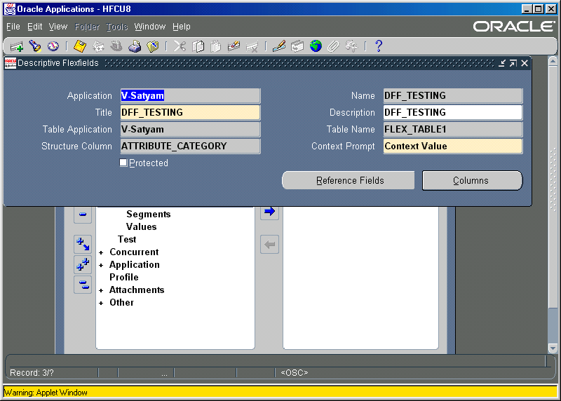
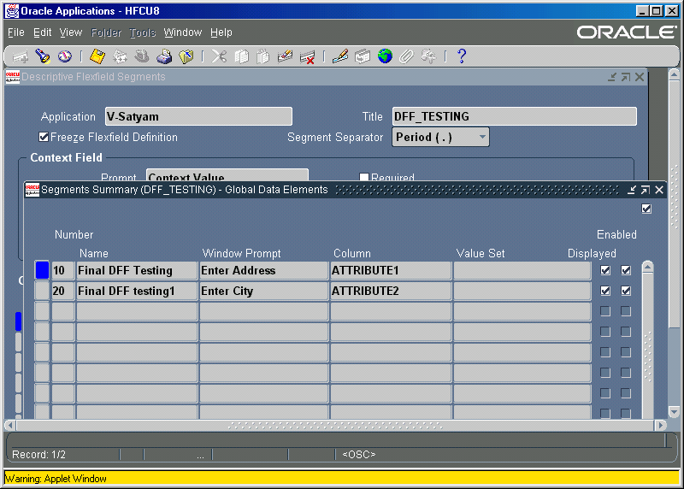

4. Create descriptive flexfield fields in your forms , Once you have the appropriate table columns and your flexfield is registered, you can build your flexfield into your application forms.

5. Create your hidden fields, you create your hidden flexfield fields as part of creating your default form block from the database table (or view). Set the canvas property of the flexfield fields to null.
(Attach TEXT_ITEM PC for Hidden Fields)

6. Attach TEXT_ITEM_DESC_FLEX PC , ENABLE_LIST_LAMP Dummy LOV for descriptive flexfield

7. Have to add following content into below 7 Triggers at Form Level.

PRE–QUERY
FND_FLEX.EVENT(’PRE–QUERY’);

POST–QUERY
FND_FLEX.EVENT(’POST–QUERY’);

PRE–INSERT
FND_FLEX.EVENT(’PRE–INSERT’);

PRE–UPDATE
FND_FLEX.EVENT(’PRE–UPDATE’);

WHEN–VALIDATE– RECORD
FND_FLEX.EVENT(’WHEN–VALIDATE–RECORD’);

WHEN–NEW–ITEM–INSTANCE
FND_FLEX.EVENT(’WHEN–NEW–ITEM–INSTANCE’);

WHEN–VALIDATE–ITEM
FND_FLEX.EVENT(’WHEN–VALIDATE–ITEM’);

8. Define Flexfield in When New Form Instance Trigger at Form Level.

FND_DESCR_FLEX.DEFINE(BLOCK=>'XXDFF_TABLE',
FIELD=>'ENAME',
APPL_SHORT_NAME=>'V-SAT',
DESC_FLEX_NAME=>'DFF_TESTING');

BLOCK - is the block name in the form
FIELD - Field which is acting as DFF
APPL_SHORT_NAME – Application Short Name
DESC_FLEX_NAME - Name of the Descriptive Flex Field you have given at the time of Registration.

