General Ledger – Technical

- Overview
- SOB -Main Tables
- Journals-Tables
- Budgeting-Tables

Opening the Period
|
Enter Transactions
(Gl_JE_BATCHES,GL_JE_HEADERS,GL_JE_LINES) |
Review & Modify
|
Post (Gl_Balances)
|
Review/Revalidate/Report
|
Close the Period
Enter in GL Imported From Subledger
(Allocations/Adjustments) (Oracle Subledgers & Non | Oracle systems)
|-------------------------------|
Transactions Transactions
(Manually keyed) (Automatically Generated)
|
1. Reversal JV(Nullifying Impact of Wrong Entered JV)
2. Recurring JV /Formula JV (Rent,Paper etc repeated …)
3. Allocations (Special Case of Recurring JV)
4. Revaluation (Rev. is adjustment for Tr.currencies /Acc currency)
5. Consolidations (Dummy parent balance for Child accounts)

GL_CODE_COMBINATIONS :
Stores valid account combinations for each Accounting Flexfield structure within your Oracle General Ledger application. Associated with each account are certain codes and flags, including whether the account is enabled,whether detail posting or detail budgeting is allowed, and others.
GL_Balances:
GL_BALANCES stores actual, budget, and encumbrance balances for detail and summary accounts. This table stores functional currency, foreign currency, and statistical balances for each accounting period that has ever been opened. ACTUAL_FLAG is either 'A', 'B', or 'E' for actual, budget, or encumbrance balances, respectively.

ENCUMBRANCE_TYPES
Stores information about encumbrance types, including their IDs and descriptions. This table corresponds to the Encumbrance Types form. This table has no foreign keys, other than the standard Who columns.
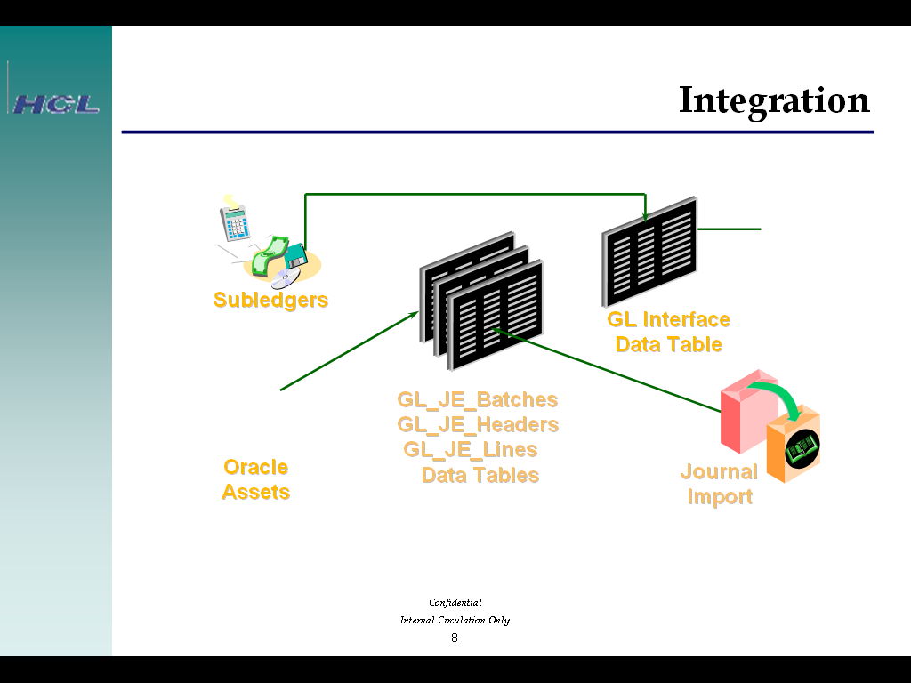

Consolidations & Conversion Tables

GL_CONSOLIDATION: Stores information about your consolidation mappings. Each row includes a mapping's ID, name, description, and other information. This table corresponds to the first window of the Consolidation Mappings form. You need one row for each consolidation mapping you define.
GL_CONSOLIDATION_ACCOUNTS: Stores the account ranges that you enter when you consolidate balances using the Transfer Consolidation Data form. This table corresponds to the Account Ranges window of the Transfer Consolidation Data form.

GL_DAILY_RATES stores the daily conversion rates for foreign currency transactions. It replaces the GL_DAILY_CONVERSION_RATES table. It stores the rate to use when converting between two currencies for a given conversion date and conversion type.

GL_DAILY_BALANCES stores daily aggregate balances for detail and summary balance sheet accounts in sets of books with average balances enabled.
Over view of Journals

Journals are of following types
- Statistical JV (UOM & Quantity are must, Curr as STAT)
- Mixed JV ( UOM,Quantity & Cr/Db accounts )
- Monetary JV (Credit/Debits are required)
- Reversal Journal (Reversal Journal reverse JV which r marked for Reversal)
If JV not posted, just open the JV and make amt as Zero.
5) Recurring JV: I) Standard- Db Rent a/c 10000
ii) Formula - Db Act1 (Form. To cal amt)
iii) Skeleton-Db Act1 Amt based on case to case user enters)
6) Mass Allocation (special Type of Recurring JV)

Journal Tables
- Journals
GL_INTERFACE (For Journal Import) is the table you use to import journal entry batches through Journal Import. You insert rows in this table and then use the Import Journals form to create journal batches. You must supply values for all NOT NULL columns. For a complete description of how to load this table, see the Oracle General Ledger User Guide.

GL_INTERFACE_CONTROL is used to control Journal Import execution. Whenever you start Journal Import from the Import Journals form, a row is inserted into this table for each source and group id that you specified. When Journal Import completes, it deletes these rows from the table.

GL_JE_BATCHES stores journal entry batches. Each row includes the batch name, description, status,running total debits and credits, and other information. This table corresponds to the Batch window of the Enter Journals form. STATUS is 'U' for unposted, 'P' for posted, 'S' for selected, 'I' for in the process of being posted. Other values of status indicate an error condition. STATUS_VERIFIED is 'N' when you create or modify an unposted journal entry batch. The posting program changes STATUS_VERIFIED to 'I' when posting is in process and 'Y' after posting is complete.
GL_JE_HEADERS stores journal entries. There is a one-to-many relationship between journal entry batches and journal entries. Each row in this table includes the associated batch ID, the journal entry name and description, and other information about the journal entry. This table corresponds to the Journals window of the Enter Journals form. STATUS is 'U' for unposted, 'P' for posted. Other statuses indicate that an error condition was found.

GL_JE_CATEGORIES_TL stores journal entry categories. Each row includes the category name and description. Each journal entry in your Oracle General Ledger application is assigned a journal entry category to identify its purpose. This table corresponds to the Journal Categories form

Journal & Period Tables
GL_JE_LINES : Stores the journal entry lines that you enter in the Enter Journals form. There is a one-to-many relationship between journal entries and journal entry lines. Each row in this table stores the associated journal entry header ID, the line number, the associated code combination ID, and the debits or credits associated with the journal line. STATUS is 'U' for unposted or 'P' for posted.
GL_PERIODS :Stores information about the accounting periods you define using the Accounting Calendar form. Each row includes the start date and end date of the period, the period type, the fiscal year, the period number, and other information. There is a one-to-many relationship between a row in the GL_PERIOD_SETS table and rows in this table.

GL_PERIOD_TYPES stores the period types you define using the Period Types form. Each row includes the period type name, the number of periods per fiscal year, and other information. YEAR_TYPE_IN_NAME is 'C' for calendar or 'F' for fiscal. This determines the system-assigned name of your accounting period in the Accounting Calendar form.

GL_AUTHORIZATION_LIMITS stores information about authorization limits for employees. Each row contains an employee and the employee's authorization limit. This table corresponds to the Journal Authorization Limits window of the Journal Authorization Limits form

GL_APPLICATION_GROUPS replaces FND_APPLICATION_GROUPS. It holds rows for individual application product groups. For each application product group listed in this table, Oracle General Ledger's Accounting Calendar form maintains a separate set of accounting period statuses. Thus for each period defined in the Accounting Calendar form, a row is inserted into GL_PERIOD_STATUSES for each row in GL_APPLICATION_GROUPS.

Revaluation Tables
GL_REVALUATIONS :Stores Revaluation definitions. Each row includes a revaluation?s id, name, description, the corresponding set of books, the currency or currencies to be revalued, and other revaluation options. They include the currency conversion options, the unrealized gain account, the unrealized loss account, and the automatic post flag. There is a one-to-many relationship from each revaluation stored in this table to the revaluation account ranges stored in GL_REVAL_ACCOUNT_RANGES.

GL_REVAL_ACCOUNT_RANGES stores the account ranges to be processed for a revaluation. Each row includes the revaluation id, the account range and two flags to indicate whether the balancing and natural account segments are parent values that should be expanded within the specified account range. Each account range stored in this table should be related to one and only one revaluation defined in GL_REVALUATIONS.

GL_RX_TRIAL_BALANCE_ITF stores the data for country-specific RX trial balance reports. Each time a country-specific RX trial balance report is run, a new set of data is inserted into this table.

GL_SETS_OF_BOOKS stores information about the sets of books you define in your Oracle General Ledger application. Each row includes the set of books name, description, functional currency, and other information. This table corresponds to the Set of Books form

GL_SUSPENSE_ACCOUNTS stores the additional suspense accounts you have specified for each source and category. This is the base table for the Suspense Accounts form in your Oracle General Ledger application. The posting program in your Oracle General Ledger application uses the suspense account you specify in the Suspense Accounts form to balance journal entries where running debits and running credits are not equal.

Budgeting
Budgeting is possible in Two ways
1) Online Budgeting Control
2) Post mortem Verification with transactions.
Setting up Budget is a three step process:
- Define Budget (Name , Duration)
- Define Budget Organization (A group of A/c heads(ranges) for each range we define a parameter
- Enter Budget Amounts for Budget Organization.
Budget Tables
GL_BUDGETS:
GL_BUDGETS stores information about your budgets. Each row includes a budget's name, first and last periods, date created, and status. This table corresponds to the Define Budget form. Oracle General Ledger supports only one budget type ('STANDARD'), so you can uniquely identify a row with only the budget name. The CURRENT_VERSION_ID column is not currently used.

GL_BUDGET_TYPES stores information about budget types. Oracle General Ledger supports only one budget type, 'STANDARD'. Therefore, this table always contains only one row. This table has no foreign keys other than the standard Who columns

GL_BUDGET_ASSIGNMENTS stores the accounts that are assigned to each budget organization. Each row includes the currency assigned to the account and the entry code for the account. The entry code is either 'E' for entered or 'C' for calculated. This table corresponds to the Account Assignments window of the Define Budget Organization form.

GL_BUDGET_INTERIM is used internally by Oracle General Ledger applications to post budget balances to the GL_BALANCES table. Rows are added to this table whenever you run the budget posting program. The budget posting program updates the appropriate budget balances in GL_BALANCES based on the rows in this table, and then deletes the rows in this table that it used.

